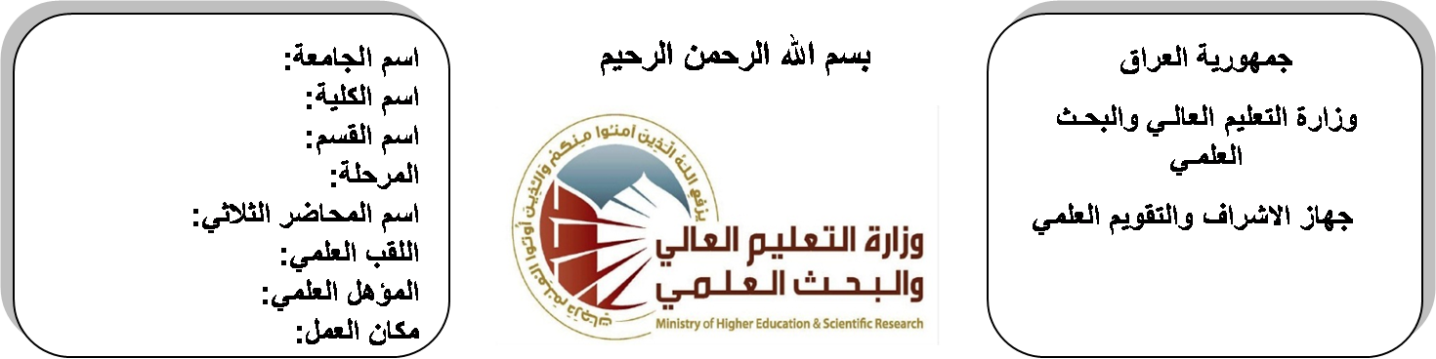

**University: Diyala University**

**College: College of Engineering**

**Department: Electronic Engineering**

**Stage: First**

**Lecturer name:** **Ibrahim Saadoon Fatah**

**Qualification: M.Sc**

**Place of work: Electronic Dept.**

**Republic of Iraq**

**Ministry of Higher Education**

**& Scientific Research**

**(( Annual teaching plan form))**

|  |  |  |  |  |
| --- | --- | --- | --- | --- |
| **Lecturer Name** | **Ibrahim Saadoon Fatah** | | | |
| **Email** | **saadon@yahoo.com** | | | |
| **Subject** | Mathematics I | | | |
| **Aims** | The aim of this subject is to make the students ready to undestand and comprehend the scientific theories and their applications related to their field of the study. | | | |
| **Textbooks** | Calculus by Thomas | | | |
| **Additional Textbooks** | Calculus by James Stewart ,Barbara Frank. | | | |
| **Assessments** | **First Semester** | **Second Semester** | **Laboratory** | **Final Exam** |
| 20% | 20% |  | 60% |
| **Notes** |  | | | |

**Schedule Weekly Lessons - First Semester**

|  |  |  |  |  |
| --- | --- | --- | --- | --- |
| **Week** | **Date** | **Lectures** | **Lab. Experments** | **Notes** |
| 1 | **27/9** | Limit & Inequalities |  |  |
| 2 | **4/10** | Trigonometry ,Analytic Geometry |  |  |
| 3 | **11/10** | Sets, Relations |  |  |
| 4 | **18/10** | Functions (algebraic and trigonometric) |  |  |
| 5 | **24/10** | Differentiation and Integration |  |  |
| 6 | **1/11** | Transcendental Functions |  |  |
| 7 | **8/11** | Inverse Trigonometric |  |  |
| 8 | **15/11** | Natural Logarithmic |  |  |
| 9 | **22/11** | Exponential and Power |  |  |
| 10 | **29/11** | .Graphs , Derivatives and Integrals |  |  |
| 11 | **6/12** | Area Between Curves  Volume of Revolution |  |  |
| 12 | **12/12** | Length of the Curve  Surface Area of Revolution |  |  |
| 13 | **20/12** | Hyperbolic Function  Inverse Hyperbolic |  |  |
| 14 | **27/12** | Differentiation and Integration |  |  |
| 15 | **3/1** | Method of Integration  Trigonometric Substitutions |  |  |
| 16 | **10/1** | Quadratics, Partial fractions, by parts, Further substitutions |  |  |
| Half Year holiday | 15/1 to  1/2 |  |  |  |

**Lecturer Signature Head of Dept. Signature Dean Signature**

**Schedule Weekly Lessons - Second Semester**

|  |  |  |  |  |
| --- | --- | --- | --- | --- |
| **Week** | **Date** | **Lectures** | **Lab. Experments** | **Notes** |
| 1 | **21/2** | Representation of vectors in space (i,j,k) unit vectors |  |  |
| 2 | **28/2** | Scalar Product |  |  |
| 3 | **6/3** | Vector Product. |  |  |
| 4 | **13/3** | Complex Numbers  Invented Number System |  |  |
| 5 | **20/3** | The Argent Diagram  Addition, Subtraction |  |  |
| 6 | **27/3** | Product, Quotient, Power and Roots |  |  |
| 7 | **3/4** | Polar Coordinate System |  |  |
| 8 | **10/4** | Polar Coordinate System |  |  |
| 9 | **17/4** | Graphs of Polar Equations |  |  |
| 10 | **24/4** | Graphs of Polar Equations |  |  |
| 11 | **1/5** | Plane Area in Polar coordinates |  |  |
| 12 | **8/5** | Plane Area in Polar coordinates |  |  |
| 13 | **15/5** | Plane Area in Polar coordinates |  |  |
| 14 | **22/5** | Matrices |  |  |
| 15 | **29/5** | Matrices |  |  |
| 16 | **2/6** | Determinants, . Inverse of a Matrix |  |  |

**Lecturer Signature Head of Dept. Signature Dean Signature**